**Results and Discussion**

**Microbiome Composition Across Individuals and Treatment-Free Conditions**

Initial 16S rRNA sequencing revealed substantial inter-individual variation in the baseline microbiome composition of the 16 included human donors. As shown in Figure 1, the relative abundance of dominant families such as *Bacteroidaceae*and *Prevotellaceae* differed considerably among samples, with some microbiomes displaying a balanced microbial distribution. Even in the absence of added substrates (FBB0 vs. FBB16), notable compositional shifts occurred after 16 hours of in vitro fermentation, indicating that microbial communities undergo spontaneous restructuring over time under fermentation conditions.

**Microbiome Alpha Diversity Responses to Treatments**

Alpha diversity was evaluated using Shannon, Chao1, Simpson, and Faith’s Phylogenetic Diversity metrics (Figure 2). Treatments containing vitamins—especially those incorporating synergistic components such as fiber or polyphenols—consistently promoted higher microbial diversity. In particular, the “vitamin,” “vitamin with fiber,” “vitamin (synergistic),” and “postbiotic” categories were associated with increased richness and evenness. In contrast, the “polyphenol” and “fiber synergistic effect” treatments frequently led to reduced alpha diversity, suggesting possible selective growth inhibition or niche dominance induced by these substrates. These trends were consistent across all individual microbiomes, emphasizing treatment-specific influences on community complexity.

**Beta Diversity: Community Shifts in Response to Treatment**

To assess global shifts in microbial composition, beta diversity was analyzed using four dissimilarity metrics: Bray–Curtis, Jaccard, unweighted UniFrac, and weighted UniFrac. Principal coordinate analyses (PCoA; Figure 3) revealed that each individual microbiome exhibited a unique compositional trajectory post-fermentation. Notably, polyphenol treatments drove a convergent shift in community composition across multiple microbiomes, implying a strong, homogenizing effect on community structure. This trend was corroborated by Figure 4, where the polyphenol-treated samples clustered distinctly from other treatment categories. In contrast, vitamin-based treatments (including synergistic and postbiotic combinations) resulted in more modest and variable shifts, often overlapping with each other, suggesting comparable influences on microbial community dynamics.

**Identification of Differentially Abundant Genera**

PERMANOVA based on Bray–Curtis distances identified several genera with significantly altered abundances across treatment categories. As visualized in the heatmap (Figure 5), treatments involving red and green acerola (vitamin C sources), particularly in synergistic combinations, led to decreased levels of *Escherichia-Shigella*, *Coprococcus*, and *Anaerostipes*, while increasing the abundance of health-associated taxa such as *[Eubacterium] ruminantium group*, *Oscillibacter*, *UCG-003*, *Odoribacter*, and *[Eubacterium] eligens group*.

Similarly, fiber-rich treatments (OGB 28%, Lantmännen OBG-29%) showed coherent effects, including reduced levels of *Gemmiger*, *UCG-002*, and *Lachnospira*. These taxa-level responses highlight the functional specificity of microbiota toward different prebiotic components and support the idea that compositional shifts can be guided by substrate identity.

**Microbiome Health Evaluation Using PPIa and GMHI**

The health implications of these compositional changes were quantified using two composite indices: the Prebiotic Potential Index adjusted (PPIa) and the Gut Microbiome Health Index (GMHI) (Table 2). PPIa values were highest in samples treated with inulin and red acerola (20% vitamin C), both of which enriched beneficial genera while suppressing harmful taxa. Conversely, the polyphenol-rich Aronox PE 40% consistently exhibited negative PPIa values across multiple microbiomes, suggesting potential adverse effects on microbial health.

GMHI further stratified the samples by health status, integrating species-level signatures associated with health prevalence. Microbiomes S3, S8, and S16 exhibited the healthiest profiles, while S5, S6, and S14 were less favorable. Treatments involving vitamins and synergistic formulations tended to improve GMHI, while polyphenol-only treatments were more frequently associated with reduced scores.

**Summary and Implications**

This study demonstrates that different prebiotic and functional ingredients elicit distinct microbiome responses during in vitro fermentation. Vitamin-based treatments, especially those paired with fiber or in postbiotic formats, support higher microbial diversity and improved health indices. Polyphenols, though biologically active, may exert selective pressures that reduce diversity and negatively affect community health depending on context and concentration.

Together, these findings emphasize the importance of considering substrate-specific and host-specific effects in designing microbiome-targeted interventions. The integration of compositional, diversity, and health index analyses offers a holistic framework to evaluate prebiotic efficacy in complex gut ecosystems.

**Figures and Tables**

**Figure 1.** **Relative abundance profile of microbial families across sixteen different human microbiomes.** FBB0 represents the fecal buffer blank at time 0, while FBB16 corresponds to the buffer after 16 hours of fermentation. Microbiome profiles vary noticeably among individuals. In some cases, *Bacteroidaceae* is the most abundant family, whereas in others, *Prevotellaceae* dominates. Certain microbiomes exhibit a relatively balanced distribution of taxa. Additionally, microbiome composition shifts substantially after 16 hours of fermentation, even in the absence of any treatment.



**Table 1. Sample names and categorized treatment groups.** A total of 21 different samples were classified into nine treatment categories: prebiotic fiber, prebiotic control, vitamin with fiber, vitamin, vitamin synergistic, vitamin synergistic effect, polyphenols, fiber synergistic effect, and postbiotic. These samples were used in the fermentation experiment.

**Figure 2. Alpha diversity of individual microbiomes after 16 hours of fermentation across nine treatment categories.** Alpha diversity was assessed for each individual microbiome after fermentation using four different metrics: Shannon, Chao1, Simpson, and Faith’s Phylogenetic Diversity (PD). Across all diversity indices, treatments including postbiotic, vitamin, vitamin (synergistic effect), vitamin (synergistic), and vitamin with fiber consistently exhibited higher alpha diversity. In contrast, treatments such as polyphenols and fiber synergistic effect were associated with lower diversity. These trends were consistent across different individual microbiomes

(B)

**Figure 3. Microbiome compositional shifts after 16 hours of fermentation under four distance metrics.**  
Beta diversity was calculated using four metrics: Bray–Curtis, Jaccard, unweighted UniFrac, and weighted UniFrac. Principal component analysis (PCA) was performed on each distance matrix, and the first two principal components were plotted for visualization. Arrows represent the directional shift of each microbiome from the baseline (FBB0) to the post-fermentation state across different treatment categories. While individual microbiome profiles primarily drive the clustering, the polyphenol treatment notably shifts multiple microbiomes toward a similar compositional endpoint after fermentation.

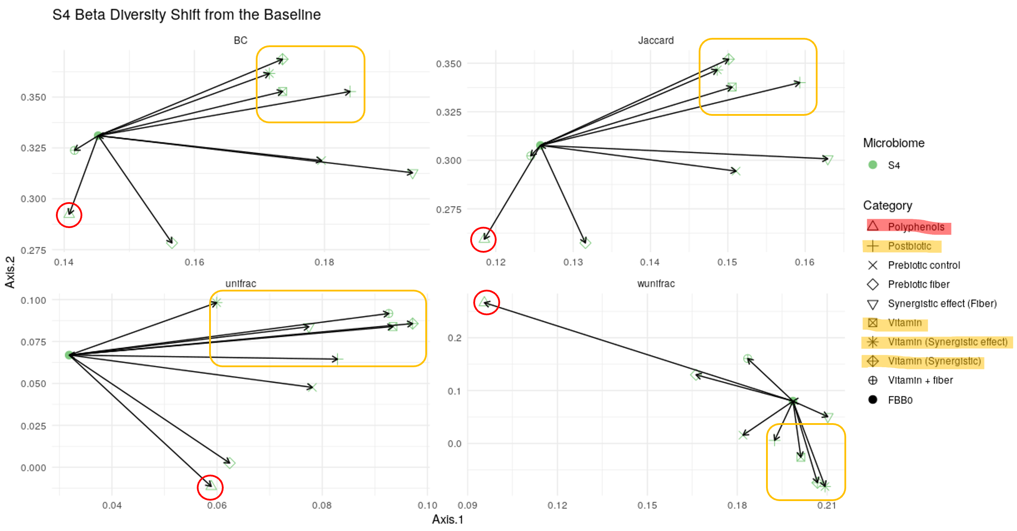

**Figure 4. Classification of treatment category effects based on microbiome similarity.**  
Microbiome beta diversity shifts from the baseline (FBB0) were visualized using principal component plots based on four distance metrics for each individual microbiome. The polyphenol treatment consistently exhibited a distinct effect on microbiome composition compared to other categories. In contrast, treatments including postbiotic, vitamin, vitamin (synergistic effect), and vitamin (synergistic) displayed similar patterns of beta diversity change.

**Figure 5. Heatmap of differentially abundant genera identified by PERMANOVA across samples.**  
Permutational Multivariate Analysis of Variance (PERMANOVA) was used to identify genera with significantly different abundances across treatments. Log<sub>2</sub>-transformed abundance ratios were calculated for each genus, and results were visualized as a heatmap. Warmer colors indicate higher relative abundance. Taxa are organized by co-occurrence patterns, and samples are clustered based on microbial community similarity. Carrot juice with green acerola, red acerola (20% vitamin C), green acerola (34% vitamin C), and the combination of red and green acerola (20% vitamin C) induced similar microbial shifts, characterized by decreased abundance of Escherichia-Shigella, Coprococcus, and Anaerostipes, and increased abundance of [Eubacterium] ruminantium group, Oscillibacter, UCG-003, Odoribacter, and [Eubacterium] eligens group. Similarly, treatments with OGB 28% (OatWell Bran) and Lantmännen OBG-29% GF resulted in comparable effects, including reduced levels of Gemmiger, UCG-002, [Eubacterium] ventriosum group, Lachnospira, Acutalibacter, Monoglobus, and Fusicatenibacter.

(A)

(B)

**Table 2. Gut Microbiome Health Indices: PPIa and GMHI.** **(A) Prebiotic Potential Index (PPIa):** Genera were classified as beneficial or harmful based on previous studies (see Supplementary Materials). Read counts were summed separately for beneficial and harmful taxa, and the Prebiotic Potential Index (PPIa) was calculated as: **PPIₐ = (Reads mapped to beneficial taxa – Reads mapped to harmful taxa) / Total reads.** A higher PPIa value indicates a greater potential for promoting a healthy gut microbiome. Aronox PE 40% polyphenolsshowed a negative impact on gut microbial health across multiple microbiomes, whereas inulin and red acerola (20% vitamin C) demonstrated a more positive effect. **(B) Gut Microbiome Health Index (GMHI):** GMHI was calculated based on the richness of health-prevalent versus health-scarce species. A higher GMHI score reflects a healthier microbiome state. Microbiomes S5, S6, and S14 showed relatively poor health status, while S3, S8, and S16 appeared healthier. Polyphenol treatments were generally associated with negative effects on microbiome health, whereas treatments with vitamins, vitamin synergistic combinations, and vitamin synergistic effects tended to improve microbiome health.